**WOLDS POLICE**

**Quarterly Briefing – November 2021**

|  |
| --- |
| **YOUR NEIGHBOURHOOD POLICING TEAMS** |
| Sgt Kelly Palmer  Beat Manager PC Rich Precious  PCSO Jo Drake  PCSO Martin Pearson  Sgt Andy Burtenshaw  Beat Manager PC Daniel Green  PCSO Iwona Blachut  PCSO Teresa Key  Sgt Andy Burtenshaw  Beat Manager PC Daniel Green  PCSO Jad Mohamed  Sgt Andy Burtenshaw  Beat Manager PC Daniel Green  PCSO Nigel Wass (temp)  PCSO Nicola Stuchfield  Sgt Kelly Palmer  Beat Manager PC Rich Precious  PCSO Justin Mekkaoui |

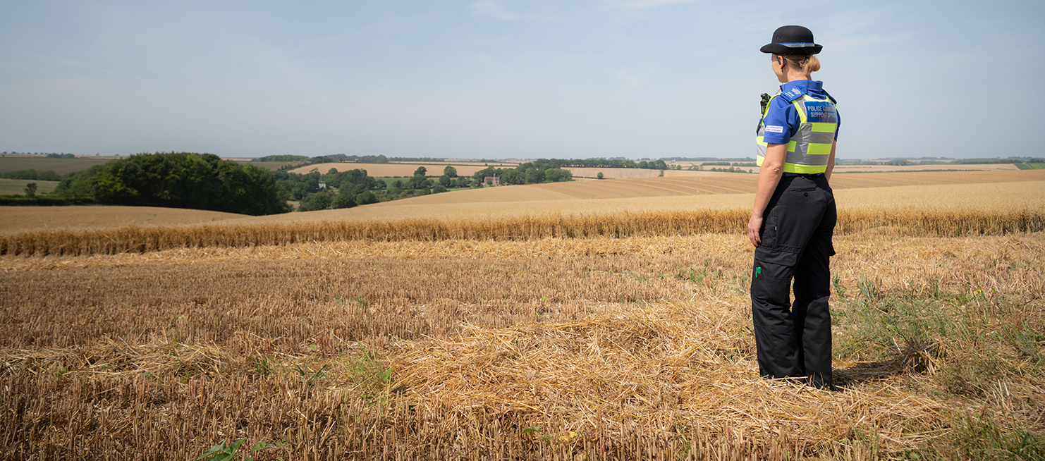

Search:**South Holland Police**

|  |
| --- |
| **INTRODUCTION** |
| Wolds Quarterly briefing November 2021  This is most likely my last quarterly briefing as Wolds Neighbourhood Inspector before I retire, after 30 years of service with Lincolnshire Police.  I have spent some time reflecting on the changes in the demand and way that we police our communities and as you can imagine there have been some significant changes.  When I started, the majority of the time spent by officers was dealing with fairly straightforward matters and crime.  Now the majority of time is dealt with keeping people safe and safeguarding often having to support our partners who are also stretched. The crime types we deal with become increasingly complicated and sophisticated with advancements in technology. With officers being required to gather all sorts of evidence in all sorts of formats. Such as CCTV, computers, mobile phones, and evidence held on social media sites as well as physical evidence. Officers have to be adept in gathering all this evidence and information, in order to ensure that victims and suspects are treated fairly.  All of this takes time, and it can be difficult when you are the person involved in that investigation to understand that this takes time and is often beyond the control of the officers dealing. Officers must present enough evidence to ensure that the evidential threshold of beyond all reasonable doubt is met. It is not enough to say we think that person committed the crime, we must prove that they did. And then the evidence must meet the public interest test as well, it may not be the best way of resolving the crime by taking it to court.  Officers today certainly have a far harder time of things than when I first joined, and I have every respect for those officers joining the service now who are subject to intense scrutiny and having to make some very complex on the spot decisions with often conflicting information. Officer numbers having risen from when I first joined, unfortunately then fell due to funding cuts to a similar level as to when I joined. Crime numbers and complexity have increased so it isn’t difficult to see why officers are stretched.  That said we are now I believe starting to turn a corner with more officers being recruited, so I feel I am leaving at a point where the future is far more positive than it has been for some time.  So enough of the reflections from me, I will start my briefing with the neighbourhood Police **staffing updates:**  We have been very fortunate on Wolds in the recent officer uplift and will soon be joined by another CBM (Community Beat Manager) this post will be at Louth, meaning I will have 4 Police officers across the Wolds, 2 covering the North and 2 at the South and there should be 9 PCSO posts. This will really make a difference to the team at Louth. PCSO Martin Pearson has also moved to Louth to help even out the numbers across the teams after some staffing changes.  Sgt Andy Price at Louth has a secondment to another role for a few months and so Sgt Kelly Palmer will be taking over his role in the meantime.  Kelly who was successful in her recent promotion board was our CBM at Horncastle, so it is fantastic that she is remaining in the team and I know she will make a fantastic Sgt.  We are currently recruiting an officer to come in and cover the CBM post at Horncastle temporarily whilst Kelly is away, and the successful person will support PC Dan Green and the team in the South. We have had a lot of interest in this post, which is good news and I think down to the way the team works looking at long term problem solving and being proactive.  PCSO Iliyana Edwards has now left the team to become a Police Officer with Lincolnshire Police and we wish her every success in her new role. PCSO Wass will temporarily be covering the Coningsby and Woodhall area and hopefully we will soon be in a position to recruit some new PCSO’s to the team. This does mean that sickness is also considered we have less deployable PCSO’s on our team than the 9 we should have, and we are having to really prioritise what they are doing and unfortunately, we cannot be everywhere and do everything.  DC Phil Graves has started in the team as our new ASB officer, his previous CID experience is already showing, and he has been working on a number of criminal behaviour orders for repeat offenders living in our area. These enable us to place restrictions and conditions on these offenders which if breached make them liable to arrest and court process for the breach.  In addition, as part of the uplift a rural crime team is being set up, local wildlife officer Sgt Nunn is heading up this new team and she will be working closely with the Wolds NPT on issues in this area including targeting the night-time poaching issues under Op Actaeon.  All the neighbourhood team are dedicated individuals who have joined to make a difference, and they care about the communities in which they live and work.  I am not sure at the time of writing this who my replacement will be but knowing the people who have expressed an interest in my role I know that whoever is chosen the team will be in capable hands.  Priorities for the last quarter and updates:  Fatal 4  ASB  Each month a quarterly newsletter is produced by the team and these will include in the future more specific updates for each area on the priorities and engagements happening.  In relation to Fatal 4 the teams have been undertaking engagements to educate drivers, supporting the local and national campaigns, conducting local enforcements and we have also tasked the roads Policing team and safer road teams with enforcement in our area. Unfortunately, we have still seen in our area a number of serious collisions and some of these have led to fatalities with devasting consequences to those involved. Every incident that takes place on our roads, is one too many and I know the majority of our communities support road safety as being one of our priorities. I know that there is from the team a strong focus on education and prevention alongside enforcement on our roads.  We have also been supporting community speed watch initiatives which all play the part in reminding and educating drivers. We are also starting to see results from public submitting dash cam footage to us, on the Op snap portal. By submitting footage of driving offences that you have come across whilst you are out on our roads you are helping us to make our roads a safer place to be. Please have a look at our website which explains more about Operation snap.  I am pleased that in the recent officer uplift a Road Police unit is being set up that will be based at Louth, and I think this will make a real difference to road safety on Wolds. PC Precious our CBM at Louth will be leaving the NPT next year, having been successful in his application for the new roads policing unit. Whilst I am sad to see him leave the neighbourhood policing team, I know that he will continue to work very closely with the team locally on road safety and we will soon be looking to recruit a replacement CBM for when he leaves. This will be in addition to the extra CBM from the officer uplift  The teams across Wolds are working hard to tackle ASB, and I am again renewing my appeal that if you are aware of ASB in your locality, please ensure it is reported to the Police or the ASB officer at East Lindsey District Council. Preferably report things as they are happening, at least if there is an officer available, we then may have a chance at dealing with the matter at the time but if we can’t attend, we at least can work with partners to tackle the ASB.  Often things are posted on to social media sites and are not reported to the Police, given that there are several hundred social media platforms just in our area alone as you can imagine we do not have the capacity to monitor and respond to these. I do not want officers sat behind desks and monitoring social media, they need to be out patrolling and dealing with incidents and protecting the vulnerable in our communities.  Your NPT have focussed efforts where we have been receiving ASB reports, and we have made several arrests for crimes which are being progressed, alongside ASB stepped approach and have had successful interventions with a number of young people in our area to prevent ASB. It is really important that we try and tackle these at the earliest opportunity, so that we can hopefully educate and support those who cause ASB and look at how we can successfully intervene before the behaviour becomes engrained. As a team we work to understand why things are happening and look as what we can do to prevent this. Criminalising young people is often not the answer, and the team look at each individual case to see what is happening in their lives and who we can work with to change things. Understanding things like adverse childhood experiences can have a long-term impact on that person for the rest of their lives. Often the right intervention at the right time can break that cycle and we can really make a difference.  Your NPT are also supporting the Mini Police programme, and across the Wolds the PCSO’s are delivering the programme to 11 schools in our area: Mini police is a community cohesion project that has been running successfully in primary schools across Lincolnshire since September 2018. With an unscheduled COVID break in schools the programme has been refreshed and edited to ensure it is still fit for purpose ready for the relaunch in September 2021. It is a 12-lesson engagement programme delivered to primary-aged children, predominantly years five and six (ages 9-11).  Some engagements can be delivered as full school activities.  The programme runs for two years and has been delivered by local Police Community Support Officers to enable familiarity, local knowledge, and confidence in the local policing teams. It has been designed around the concept of pupil voice, so each school has a relevant and impactive experience. Mini Police Lincolnshire has been aligned to the national Personal, Social, Health and Economic Education curriculum as it focuses on children’s personal development, which helps them be more confident, resilient, independent and develop character. It also helps them to assess and challenge age-appropriate risky situations. In addition to the mini police programme, the teams work with secondary schools and the stay safe team at headquarters to deliver a programme into secondary schools in relation to designated problems that get highlighted in our areas. This will provide support in areas where we may be having hotspot ASB issues.  In addition to the above updates the teams have also supported response colleagues in dealing with urgent incidents, such as looking for high risk missing people. They attend multi agency risk assessment meetings with partner agencies when there are concerns about children or adults who may be at risk in our area so that we can safeguard and protect the most vulnerable.  They do follow up visits for those that have been the victim of crime and ensure that when they come across safeguarding concerns these are passed on to support agencies so that people are kept safe. No day is the same for your local team and as you can imagine the safeguarding work the team do is essential, and largely unseen in the wider community.  You can see in the below charts the types of calls for service, and as you can see crime makes up 24% of that demand. Obviously, these reflect the percentage of calls for service, but this does not reflect the complexity of the incidents called in. For example, if we have a high-risk missing person, this can be very resource intensive whilst we try and locate the individual and prevent them coming to any sort of harm. Some of the figures below were impacted during lockdown and given that on Wolds we fortunately tend to have lower levels of incidents in comparison with other areas across the county this can make small increases look more significant. Wolds remains one of the safest places to live in the country and in the county and we are grateful for your help supporting us to keep it this way.  It has been a privilege to work within Wolds NPT over the last few years. The team work really hard and I am very proud of what they have achieved given all the difficulties faced during a pandemic and a reduction in staffing numbers. I know that given the uplift those new officers recruited to the team will make a noticeable difference.  Best wishes for the upcoming festive season and thank you for your support and taking the time to read my briefing. |

|  |  |  |  |
| --- | --- | --- | --- |
| Signature: | Sarah Constantine | | |
| Name: | Sarah Constantine | | |
| Neighbourhood Inspector for [Area]: | | Wolds | |
| **OUR PRIORITIES** | | |
| At the recent priority setting meeting the following priorities were set:  1, Fatal 4  2, ASB  3, Seasonal burglaries  These were the issues raised of most concern within the meeting by all present, so the NPT will be working on these priorities in addition to any daily demand.  We will also support the night-time poaching initiative into Op Actaeon, offenders often travel into our county to commit this crime trespassing on land, causing damage to property and crops, and animal cruelty both to the prey and often the dogs used in hunting. These offenders cause considerable distress and harm to our rural communities and the offenders also commit other crimes such as burglaries and thefts, often part of organised groups that commit similar offences across the country.  We are increasing rural night-time patrols to target those offenders, working with other forces and agencies to prevent and prosecute those responsible. | | |

|  |  |  |
| --- | --- | --- |
| **DEMAND ON OUR SERVICES** | | |
|  | | |
| **CRIME** | | |
|  |  | |
|  |  | |
|  |  | |
|  |  | |
| **CONTACT US AND MORE INFORMATION** | |
| A range of information and resources are available including online crime recording at [**www.lincs.police.uk**](http://www.lincs.police.uk)    Action Fraud has information about fraud and facilities for recording offences of fraud. [**www.actionfraud.police.uk**](http://www.actionfraud.police.uk)  Crime and other incidents should be reported to Lincolnshire Police on **101**    Incidents of Anti-Social Behaviour (including noise nuisance and flytipping)  can also be reported to East Lindsey District Council on **01507 601111**  A picture containing object, clock, drawing  Description automatically generated  Nextdoor is a great way of getting the latest relevant information for your area.  **www.nextdoor.co.uk**  [Image result for facebook](https://www.bing.com/images/search?view=detailV2&ccid=zypBMGkU&id=3AED67DC22CFF04AFC732AA0638B19E50B699C46&thid=OIP.zypBMGkULrdnbEuOQnTrZAHaHa&mediaurl=http://logos-download.com/wp-content/uploads/2016/03/Facebook_icon.png&exph=5000&expw=5000&q=facebook&simid=608052507486257819&selectedIndex=2)Find us on Facebook  **Louth Police** | **Horncastle Police**  Follow us on Twitter http://www.d-ss.co.uk/164-thickbox_default/twitter-bird-logo.jpg  **@LouthPolice** | **@WoldsSthPolice** | |